A Nightmare To Remember
San Francisco Horror Film Festival
June 20th 2009
Opera Plaza Cinema Theater
601 Van Ness Avenue
San Francisco, California 94102
$10.00 Admission
7-10 pm
www.anightmaretoremember.com
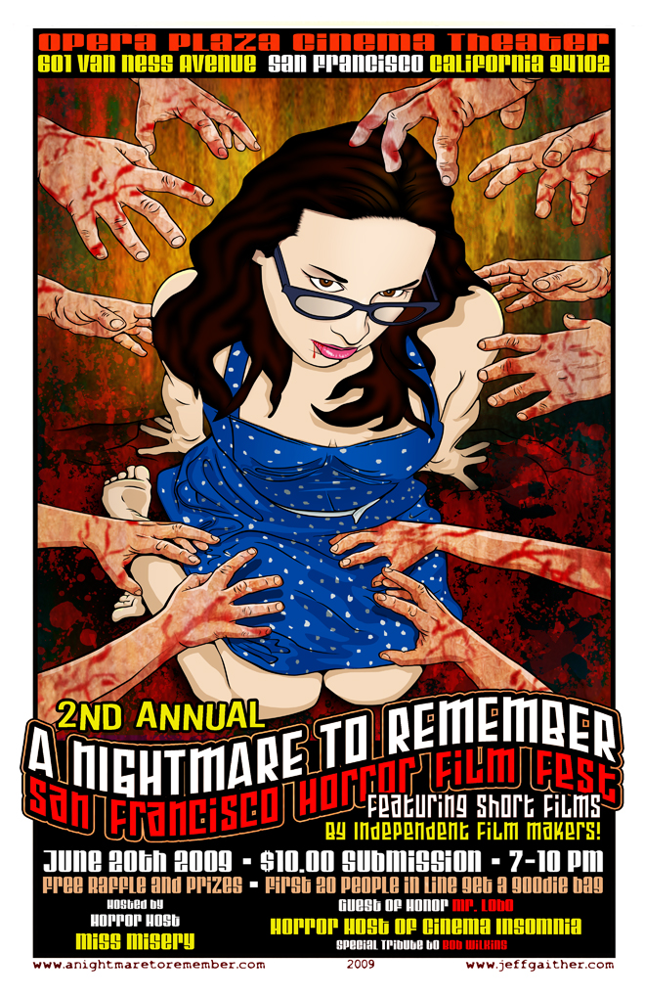
It will have been three hundred and sixty four days since the sublime dreams of San Francisco have been haunted by the ocular terrors congregated and unshackled by the creatively aberrant mind of Reyna Young. Her Nightmare To Remember film festival shall forever reverberate its unseen yet still sentient, ghosting celluloid images upon the walls of the Opera Plaza Theater.
And yet as a year of setting twilight blankets the city by the bay, such social serenity shall yet once again face something awakening like a forgotten foreboding wickedness unseen and festering beneath the city streets. For something chilling has returned to San Francisco. Something, and someone keeping the essence of humanities unconscious ghoulish midnight fears within her bosom, has once again set sites upon the Opera Plaza Theater in San Francisco California.
This June 20th in the year of 2009, A Nightmare to Remember Film Festival led by the cinematic succubae Reyna “Miss Misery” Young and her Last Doorway Productions has returned. They have risen from its graven slumber to again seduce and taunt the creative blood of independent cinema.
A Nightmare To Remember Film Festival is a three hour journey into the consciousness of horror as visually represented through short film by local and national independent horror filmmakers. The night will bring more than just the showcasing of fledgling purveyors of cinematic fright. A Nightmare To Remember Film Festival is also a celebration, one awarding the top three short films for their representing of the virtue of horror.
The night also brings the Horror Achievement award to Rick Popko and Dan West, filmmakers of future horror classics such as Monsturd and Retardead. There shall be a special tribute to Bob Wilkins, free prizes with a raffle allowing the winner to be the sole survivor of the evening’s horrific events. The first 20 people shall receive a goodie bag containing all manner of grim pleasures. Attendees shall witness the guest of honor Mr. Lobo, Horror Host of Cinema Insomnia as well as become entranced by the horror hostess of the film festival, Miss Misery.
The following purveyors of horror cinema will be sponsoring the event:
http://www.4321films.com
http://www.axwoundzine.com/
http://www.bestxxxweekever.com
http://www.bobwilkins.net
http://www.chainsawsally.org
http://www.dammitsf.com
http://www.deadhousemusic.com
http://www.fatally-yours.com
http://www.fearthedead.com
http://www.forbiddenpictures.net
http://www.fromthelandbeyond.com
http://www.horrornews.net
http://www.iamivan.com
http://www.gaithergraphix.com
http://www.lipstickteeth.com
http://www.onemediaworld.com
http://www.myspace.com/spefx1
http://www.sachorrorfilmfest.com
http://www.shock-it-to-me.com
http://www.thechainsawmafia.com
http://www.thejoeflynnshow.com
http://www.thelastdoorwayshow.com
Admission to A Nightmare To Remember Horror Film Festival is a mere monetary sacrifice to the dark cinematic Gods of $10.00 (souls and free will are not accepted payment). So my dear inquiring prey, prepare to expose your flesh and consciousness between the hours of 7-10 PM this June 20th 2009 for an event that shall never endingly disturb the most primal and darkest recesses of your psyche…You have been warned.

